


Module Code & Module Title
CU6051NI Artificial Intelligence

25% Individual Coursework
Submission: Proposal
Academic Semester: Autumn Semester 2025
Credit: 15 credit semester long module

Student Name: Prashant Rijal
London Met ID: 23048683
College ID: np01ai4a230142
Assignment Due Date: 17/12/2025.
Assignment Submission Date: 17/12/2025
Submitted To: Er. Roshan Shrestha

GitHub Link

I confirm that I understand my coursework needs to be submitted online via MST Classroom under the relevant module page before the deadline for my assignment to be accepted and marked. I am fully aware that late submissions will be treated as non-submission and a mark of zero will be awarded.

Table of Contents
1. Introduction 1
1.1. Problem Domain 1
1.2. Aim 1
2. Background 3
2.1. Related Research 3
2.1.1. Contributions to the study of SMS spam filtering: new collection and results 3
2.1.2. A Hybrid CNN-LSTM Model for SMS Spam Detection 3
2.1.3. Spam Detection Using BERT 3
2.2. Dataset Description 4
3. Solution 5
2 7
3.1. Pseudocode for Naïve Bayes 7
3.2. Pseudocode for logistic regression 9
3.3. Pseudocode for KNN 11
2.1 Flowcharts 13
3.4. Multinomial Naïve Bayes 13
3.5. Logistic Regression 14
3.6. Support Vector Machine (SVM) 15
4. Conclusion 16
3 Bibliography 17

Table Of Figures
Figure 1 Multinomial Naive Bayes 5
Figure 2 Logistic Regression 6
Figure 3 Support Vector Machine (SVM) 6
Figure 4 Naive Bayes Flowchart 13
Figure 5 Logistic Regression flowchart 14
Figure 6 Support Vector Machine (SVM) 15

Introduction
Artificial Intelligence (AI) is the field of computer science which focuses on creating computational system capable of performing, from the simplest of tasks to the most advanced and complex tasks that normally require a human. It involves the study of design and creation of intelligent agents which are equipped with reasoning (Logical or Probabilistic) to perform certain actions in a certain environment with some amount of autonomy.
AI in itself is not a single technology but a broad umbrella term for any systems that is designed to perform tasks that normally require human intelligence. It comprises of a huge range of technologies, methods, and applications that allow a machine to learn from experiences, the core fields that make AI what it is are:
- Machine Learning:
- Deep Learning:
- Computer Vision:
- Robotics:
- Natural Language Processing (NLP):
In this project we will be exploring NLP to address the text-based communication security, mainly Short Messages Service (SMS).

Problem Domain
The problem domain for this project is text-based communication security, mainly focused on identifying spam messages within the SMS communication system which is a classification problem. The SMS messages are mostly short, informal, and more often than not containing symbols and misleading content making spam detection a challenging task.

Aim
This project aims to design and develop a machine learning application which is capable of classifying SMS messages as either malicious messages (Spam) or real/legit messages (Ham), due to the growth of mobile communication SMS has become one of the primary targets for phishing attacks and unprompted marketing. This project aims to filter these types of messages in order to make user experience secure and solicit.
The project uses Supervised Machine Learning in which the model learns to map input data(Features) to output labels(Target Variable) based on the labelled dataset. For the project following concepts will be utilized:
- Natural Language Processing (NLP):
  - It is the field of AI focused on helping computers understand human language.
  - The use of NLP in this project is to clean the data (raw text) and convert it to numerical format for the computer to understand.
- Vectorization:
  - It is the process of converting non numerical data into numerical vectors for processing.
  - For the project TF-IDF (Term Frequency-Inverse Document Frequency) will be used to transform text into numerical vectors.
  - TF-IDF‘s main concept is to assign weight based on their importance.
- Classification Algorithm:
  - They are tools in ML which sorts data into categories or classes.
  - The project uses 3 distinct types of learning algorithms for classification model:
    - Naïve Bayes (Probabilistic)
    - Logistic Regression (statistical)
    - SVM Support Vector Machine (Margin Based)

Background
The SMS Spam Detection has been studied intensively in the field of NLP; the earliest approaches used the method of finding similar keywords however it was lacklustre and didn’t do well as spam patterns kept evolving, now we are at the stage where we use labelled data to identify patterns use linear and probabilistic classifiers for such tasks.

Related Research

Contributions to the study of SMS spam filtering: new collection and results
Authors: Tiago A. Almeida, José María Gómez Hidalgo, Akebo Yamakami
Year: 2011
Method: Naïve Bayes, Support Vector Machine (SVM)
This is one of the most important papers in this field as it was the paper that first introduced the “SMS Spam Collection” dataset. It compared traditional ML method like Naïve Bayes, Support Vector Machine (SVM). (Almeida, et al., 2011)

A Hybrid CNN-LSTM Model for SMS Spam Detection
Authors: Abdallah Ghourabi, Mahmood A. Mahmood, Qusay M Alzubi
Year: 2020
Method: CNN-LSTM
This paper was released and was a staple paper which showed the new concept of word embedding and semantic meaning. The researchers used CNN and LSTM model to find patter and understand sequence of sentence. (Ghourabi, et al., 2020)

Spam Detection Using BERT
Author: Thaer Sahmoud, M. Mikki
Year: 2022
Method: BERT/Transformer
This paper came after the introduction of transformer concept, instead of using just SMS data to train the model it uses BERT which is trained on the entire internet and finetunes it for SMS spam. (Sahmoud & Mikki, 2022)

Dataset Description
Dataset used: UCI SMS Spam Collection
The project utilizes the UCI SMS Spam Collection which is a public dataset sourced from University of California, Irvine’s (UCI) Machine Learning Repository.
Here are some facts that we can get from the dataset: (shown in figure 1)
- Type: .txt (the original dataset is in txt file format)
- No of rows of data: 5572
- Data Type: Unstructured English data (object)
- Class Imbalance: Heavily Imbalanced
  - Ham=4824 (86.591276%) ,
  - Spam=747 (13.408724%)
Societal or Business Relevance
- Cybersecurity: SMS phishing is a major threat in current time as it is used to steal banking details or other private information, this classifier is like the first line of defence against these types of threats.
- Business Integrity: Even now almost all top businesses and companies such as X, Meta etc rely on SMS for one time OTP but if due to constant spam email threats users stop trusting or using SMS it compromises security.
- User friendly: the spam filters automatically filter spam SMS saving time for the user and also decluttering mobile storage.

Solution
The solution developed for this implements a full machine learning pipeline:
- Data Loading
- Text Preprocessing
- Feature Extraction
- ML Algorithms
Text Preprocessing: The raw data (text) is noisy, so we apply the following techniques:
- Tokenization: Breaks sentences into words.
- Stop Word Removal: removes words like is, the, that, etc.
- Normalization: lowercases the text
- Stemming/Lemmatization: convert word to root form
Feature Extraction: Since the data is in textual form, we need to convert it to numerical form and for those following techniques is to be used:
- TF-IDF Vectorization converts text into numerical vectors. (This method was chosen because it normalizes count of words which prevents longer messages from having unfair weightage.)

Machine Learning Algorithm: Following machine learning algorithm are to be used:
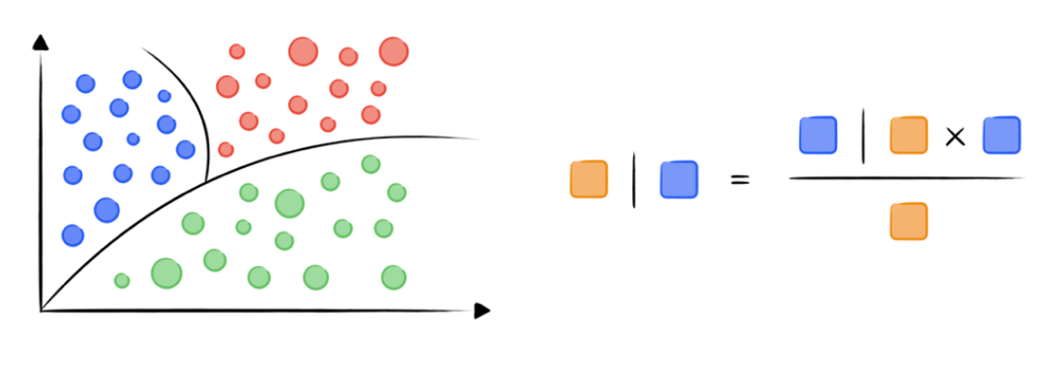
- Multinomial Naïve Bayes:
Figure 1 Multinomial Naive Bayes

  - Concept: assumes independence between features
  - Advantage: computes extremely fast and performs excellent on discrete data
  - Uses techniques like Laplace smoothing to handle unseen words preventing zero probabilities.
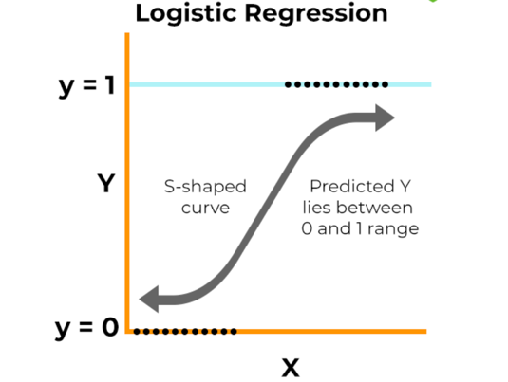
- Logistic Regression:
Figure 2 Logistic Regression

  - Concept: Learns by creating linear decision boundary between classes.
  - Advantage: it provides clear probability score rather than label making it easy to adjust threshold
  - Uses sigmoid function to provides probabilities for prediction of class.

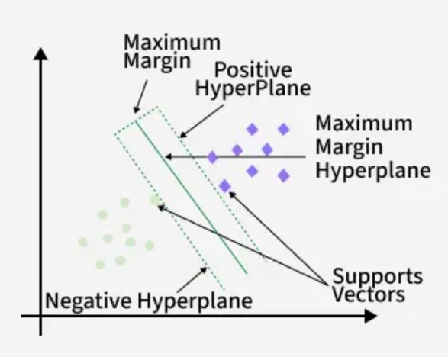
- SVM(Support Vector Machine):
Figure 3 Support Vector Machine (SVM)

  - Finds optimal hyperplane and divides classes
  - It handles high dimensional data (vectors) easily and is less likely to overfit.
  - Instance based supervised machine learning algorithm.

3.2. Pseudocodes
  - Pseudocode for Naïve Bayes:
PROCESS Naive_Bayes_Training
INPUT: Labeled_Dataset

CALCULATE P_Spam AS Count(Spam_Messages) / Count(Total_Messages)
CALCULATE P_Ham AS Count(Ham_Messages) / Count(Total_Messages)

INITIALIZE Dictionary_Spam
INITIALIZE Dictionary_Ham

FOR EACH Message IN Labeled_Dataset
IF Label IS "Spam" THEN
INCREMENT Word_Counts IN Dictionary_Spam
ELSE
INCREMENT Word_Counts IN Dictionary_Ham
END IF
END FOR

STORE P_Spam, P_Ham, Dictionary_Spam, Dictionary_Ham
END PROCESS
For Output:
PROCESS Naive_Bayes_Prediction
INPUT: New_Message, Model

SET Spam_Score TO P_Spam
SET Ham_Score TO P_Ham

FOR EACH Word IN New_Message
COMPUTE Prob_Word_Spam FROM Dictionary_Spam
COMPUTE Prob_Word_Ham FROM Dictionary_Ham

MULTIPLY Spam_Score BY Prob_Word_Spam
MULTIPLY Ham_Score BY Prob_Word_Ham
END FOR

IF Spam_Score > Ham_Score THEN
RETURN "Spam"
ELSE
RETURN "Ham"
END IF
END PROCESS

  - Pseudocode for logistic regression:
PROCESS Logistic_Regression_Training
INPUT: Dataset, Learning_Rate, Epochs

INITIALIZE Weights TO 0
INITIALIZE Bias TO 0

FOR i FROM 1 TO Epochs
FOR EACH Message IN Dataset
CALCULATE Linear_Score AS (Weights * Message) + Bias
CALCULATE Prediction AS Sigmoid(Linear_Score)

CALCULATE Error AS Label - Prediction

UPDATE Weights AS Weights + (Error * Learning_Rate * Message)
UPDATE Bias AS Bias + (Error * Learning_Rate)
END FOR
END FOR

STORE Weights, Bias
END PROCESS
For Output:
PROCESS Logistic_Regression_Prediction
INPUT: New_Message, Weights, Bias

CALCULATE Linear_Score AS (Weights * New_Message) + Bias
CALCULATE Probability AS Sigmoid(Linear_Score)

IF Probability > 0.5 THEN
RETURN "Spam"
ELSE
RETURN "Ham"
END IF
END PROCESS
  - Pseudocode for KNN:
PROCESS SVM_Training
INPUT: Dataset, Learning_Rate, Epochs, Lambda

INITIALIZE Weights AND Bias with random values

FOR i FROM 1 TO Epochs
FOR EACH Message IN Dataset
CALCULATE Position AS (Weights * Message) - Bias

IF (Label * Position) < 1 THEN
UPDATE Weights AS Weights - Learning_Rate * (2 * Lambda * Weights - (Label * Message))
UPDATE Bias AS Bias - Learning_Rate * Label
ELSE
UPDATE Weights AS Weights - Learning_Rate * (2 * Lambda * Weights)
END IF
END FOR
END FOR

STORE Weights, Bias
END PROCESS
For Output:
PROCESS SVM_Prediction
INPUT: New_Message, Weights, Bias

CALCULATE Result AS (Weights * New_Message) - Bias

IF Result >= 0 THEN
RETURN "Spam"
ELSE
RETURN "Ham"
END IF
END PROCESS

Flowcharts
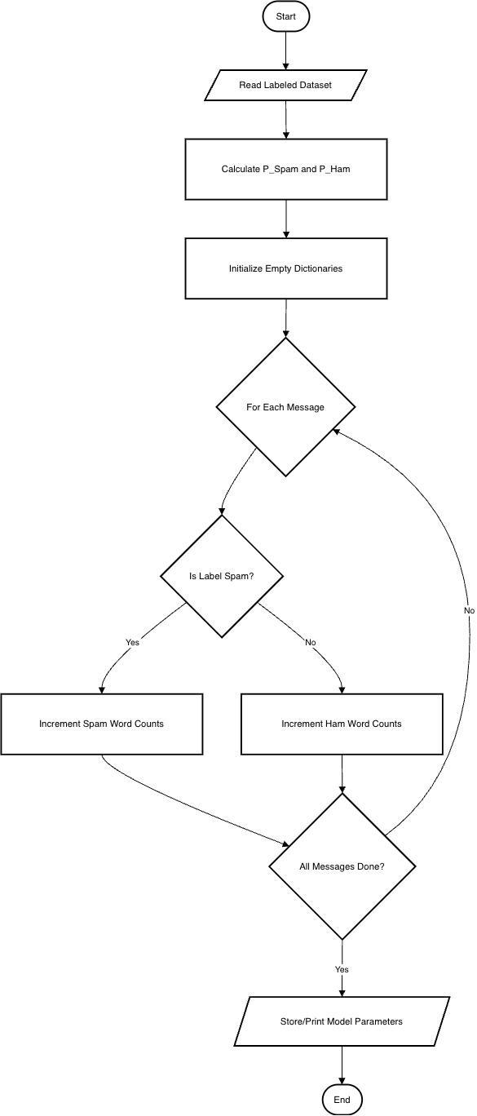
  - Multinomial Naïve Bayes :
Figure 4 Naive Bayes Flowchart

  - Logistic Regression :
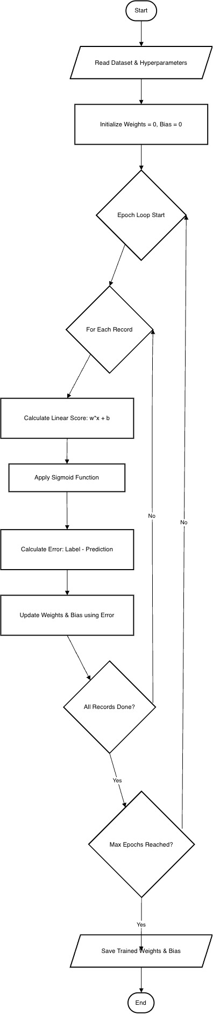
Figure 5 Logistic Regression flowchart
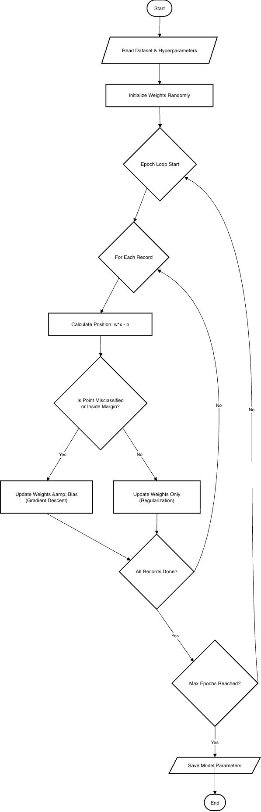
  - Support Vector Machine (SVM) :
Figure 6 Support Vector Machine (SVM)

Conclusion
The project addresses the growing cybersecurity threat of SMS phishing, scamming and tries to solve this problem by using Supervised Machine Learning and NLP. The project aims to build a classifier capable of somewhat accurately distinguish between Spam and Ham messages.
The proposed solution implements a complete ML pipeline starting from data collection to data preprocessing and finally model training and output. The comparative analysis of the three algorithms Naïve Bayes, Logistic Regression and Support Vector Machine (SVM) will ensure that the most efficient and accurate model is selected for final application.
This project is not just a academic exercise but a practical application of all the knowledge and skills accumulated. The successful implementation of this project will demonstrate the effectiveness of NLP and ML to solve the problem of SMS Scam Detection.

Bibliography
Almeida, T. A. d., Hidalgo, J. M. G. & Yamakami, A., 2011. ACM Digital Library. [Online]
Available at: https://dl.acm.org/doi/10.1145/2034691.2034742
[Accessed 14 December 2025].
Almeida, T. & Hidalgo, J., 2012. UC Irvine. [Online]
Available at: https://archive.ics.uci.edu/dataset/228/sms+spam+collection
[Accessed 12 December 2025].
Ghourabi, A., Mahmood, M. A. & Al-Zubi, Q. M., 2020. MDPI. [Online]
Available at: https://www.mdpi.com/1999-5903/12/9/156
[Accessed 14 December 2025].
Sahmoud, T. & Mikki, M., 2022. Cornell University AirXiv. [Online]
Available at: https://arxiv.org/abs/2206.02443
[Accessed 14 December 2025].

